21.Design DFA using simulator to accept even number of a’s

INPUT:

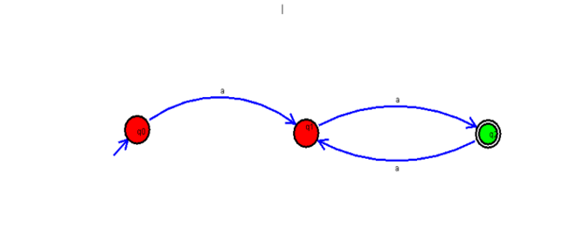

OUTPUT:

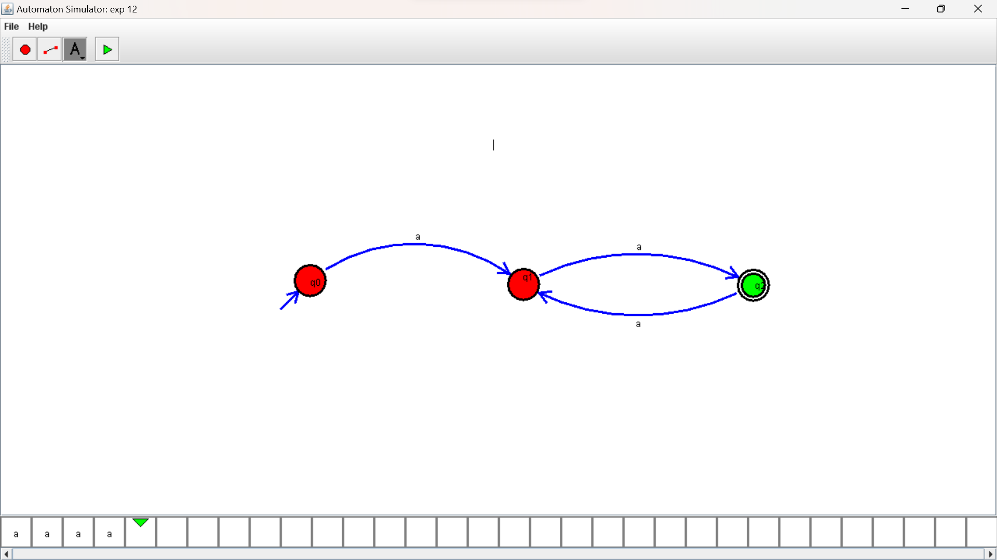

RESULTS: DFA using simulator to accept even number of a’s